|  |  |
| --- | --- |
| **WDM** | **CCWDM** |
|  |  |

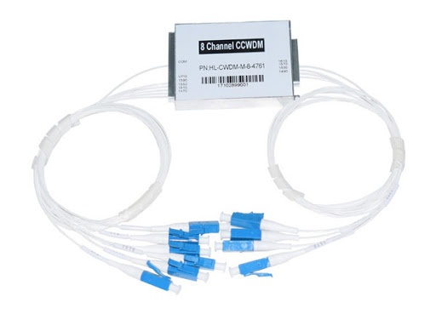

**FEATU**

**FFEATURES**

* Compact Structure & Package
* Low insertion loss
* Low Polarization Dependent Loss
* High Channel Isolation
* High Stability & Reliability

**APPLICATIONS**

* WDM Network
* CATV Network
* PON Network

* **PERFORMANCE SECTION**

|  |  |  |  |  |  |  |  |
| --- | --- | --- | --- | --- | --- | --- | --- |
| **Parameter** | | **Unit** |  |  | **Value** | |  |
| Channel Number | | CH | 4 |  | 8 |  | 18 |
| Central Wavelength | | nm |  | ITU or ITU+1 （or specified ） | | |  |
| Passband | |  |  |  | ITU±6.5 | |  |
| Product Type | | - |  |  | Mux or Demux | |  |
| Channel Spacing | | nm |  | 20 | |  |  |
| Insertion Loss | | dB | ≤1.0 |  | ≤1.5 |  | ≤3.2 |
| Channel Ripple | | dB |  |  | ＜0.5 | |  |
| Isolation | Adjacent | dB |  |  | ＞30 | |  |
| Non- | dB |  |  | ＞45 | |  |
|  | Adjacent |  |  |  |
|  |  |  |  |  |  |  |
| Directivity | | dB |  |  | ≥50 | |  |
| Return Loss | | dB |  |  | ≥45 | |  |
| Polarization Dependant | | dB |  |  | ＜0.2 | |  |
| Losses | |  |  |  |
|  |  |  |  |  |  |
| Polarization Mode | | ps |  |  | ＜0.1 | |  |
| Dispersion | |  |  |  |
|  |  |  |  |  |  |
| Connector | |  | LC/PC、SC/PC、FC/PC or specified | | | | |
| Operation Temperature | | ℃ |  |  | -5～+70 | |  |
| Storage Temperature | | ℃ |  |  | -40～+85 | |  |
| Package dimension | | mm |  | 44×25×6 | |  |  |

|  |  |  |  |  |  |  |
| --- | --- | --- | --- | --- | --- | --- |
| Product | Function | Channel | 1st Channel | Fiber Type | Connector | Input/Output |
| Series | Spacing | Length |
|  | D=Demux |  |  |  | LC/UPC |  |
|  |  |  | 0.9A=0.9m | LC/APC |  |
|  | M=Mux | 4= 4CH |  |  |
|  | 270=1270 | m G657A2 | SC/UPC | 05/05= 0.5m |
| C=CWDM | D&M= | 8=8CH |
| 290=1290 | Rb= Bare | SC/APC | 10/10= 1m |
|  | Demux & | 18= 18CH |
|  |  | fiber | FC/UPC |  |
|  | Mux |  |  |  |
|  |  |  |  | FC/APC |  |
|  |  |  |  |  |  |